Exercise 3 Report
Nguyen Tieu Phuong 20210692

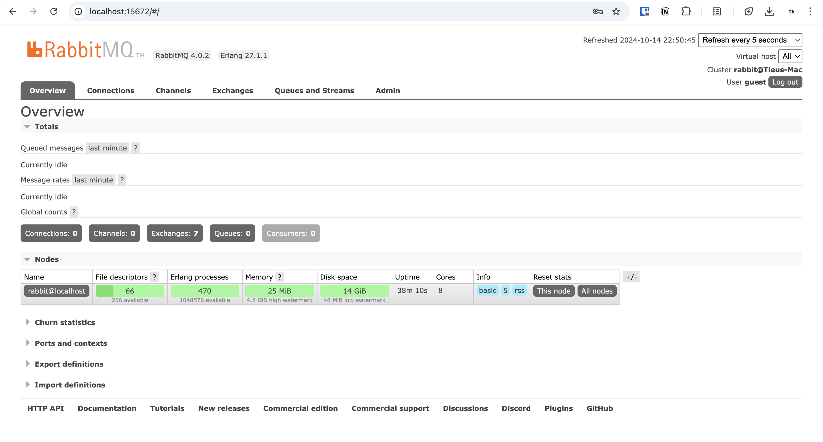
Successfully installed and set up Rabbit MQ in localhost.

In this exercise I choose Python. To run the code we need to create a virtual Python environment and then install the pika and json library.

Sender (Producer)
import pika
import json

connection = pika.BlockingConnection(pika.ConnectionParameters('localhost'))
channel = connection.channel()
channel.queue_declare(queue='data_queue')

data_packet = {
"DeviceId": 11,
"packet_no": 126,
"temperature": 30,
"humidity": 60
}

channel.basic_publish(exchange='', routing_key='data_queue', body=json.dumps(data_packet))
print(" [x] Sent data packet")

connection.close()
The code here is quite simple. We initialize the connection, create a new channel and a new queue on it to publish data later on to. We send a simple data packet in JSON format, and close the connection when done.

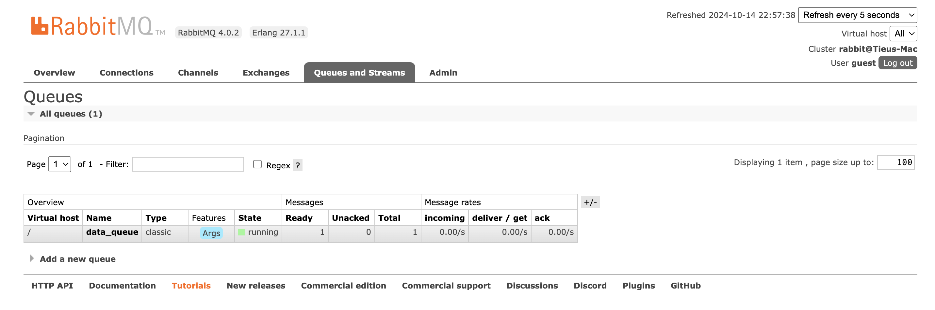
Here we can see the queue we created when we run the code.

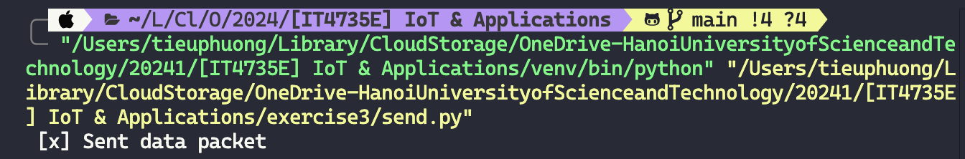
Running the program
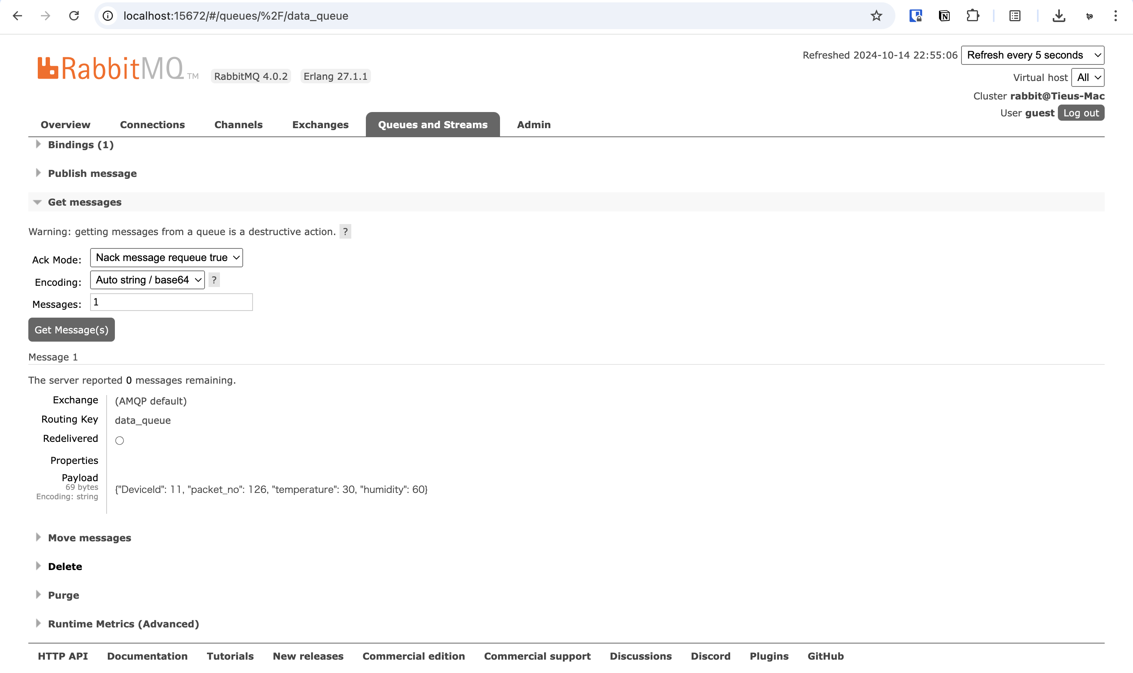
This is the message sent, can be view from RabbitMQ monitor.

Receiver (Consumer)
import pika
import json

connection = pika.BlockingConnection(pika.ConnectionParameters('localhost'))
channel = connection.channel()
channel.queue_declare(queue='data_queue')

def callback(ch, method, properties, body):
data_packet = json.loads(body)
print(f"Received Data: {data_packet}")

channel.basic_consume(queue='data_queue', on_message_callback=callback, auto_ack=True)

print(' [*] Waiting for messages. To exit press CTRL+C')
channel.start_consuming()
This code establishes the connection to RabbitMQ on localhost, then parse the data packet and print out.
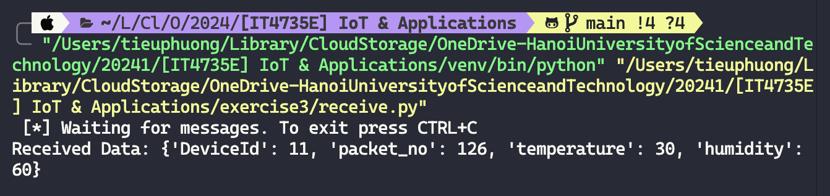
Program running

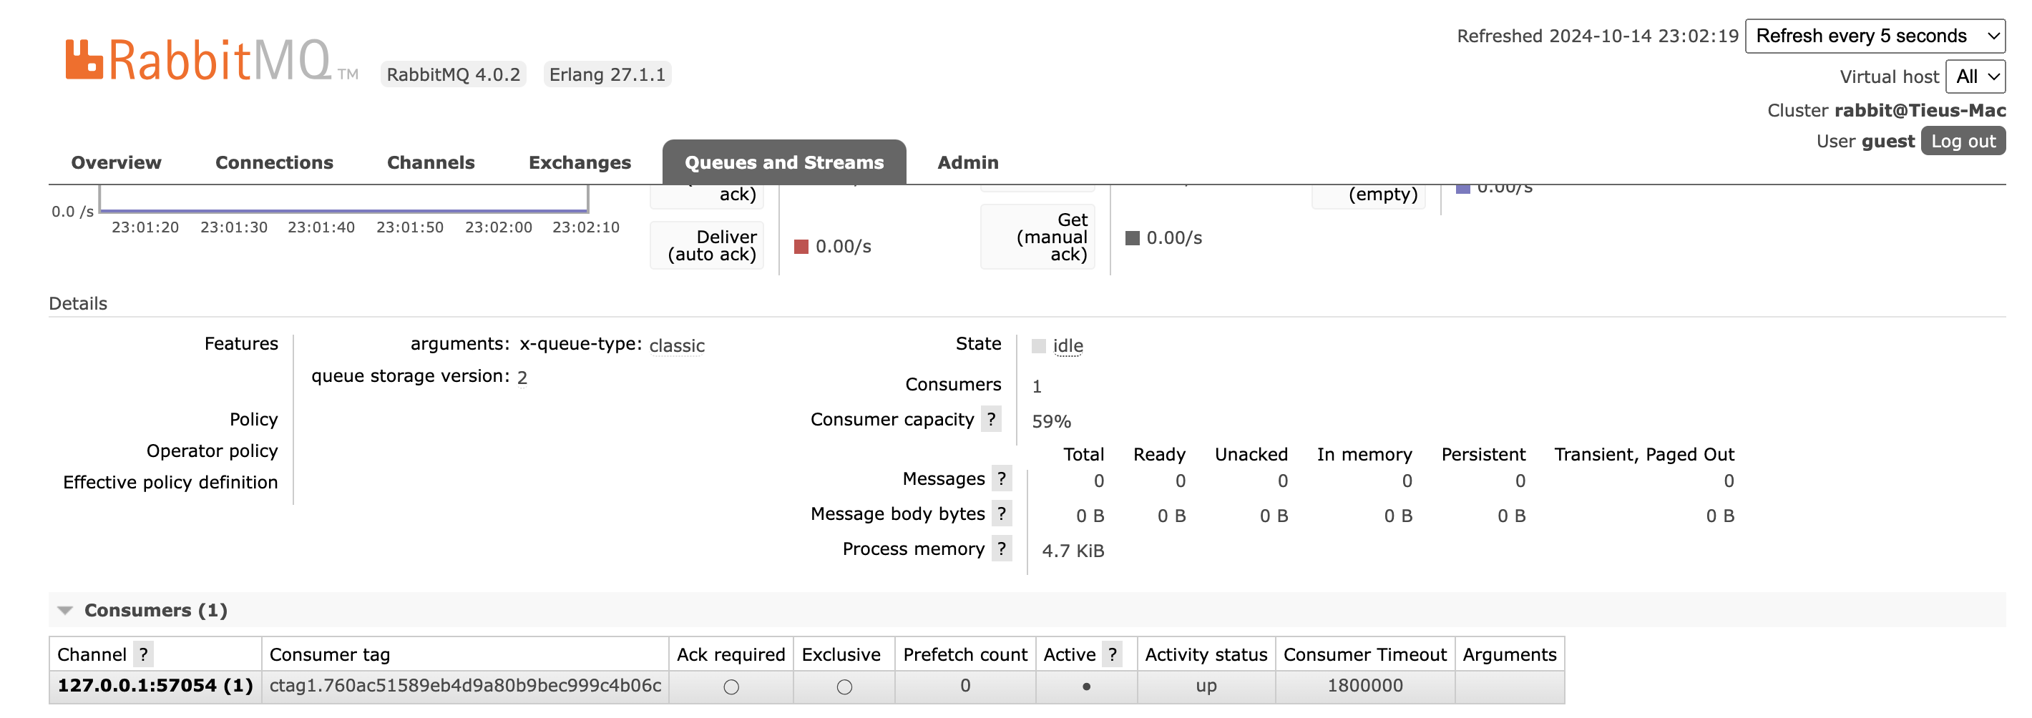
New consumer is created when we run the code. This is us listening in the queue.

